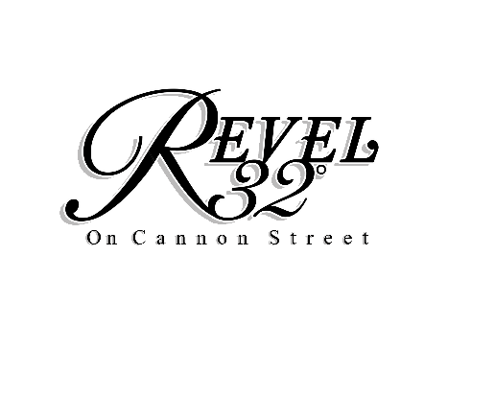

MEDIA CONTACT:
Kristin Delia
Impact PR & Communications
Kristin@prwithimpact.com
(845) 462-2979
FOR IMMEDIATE RELEASE:

Poughkeepsie’s Award-Winning Revel 32° Inks Partnership with Celebrity Chef and
Culinary Pioneer David Burke
Renowned Chef and CIA Graduate Named Preferred Partner at the Hudson Valley Event Venue

POUGHKEEPSIE, N.Y. (September 21, 2020) – Nearly one year after its debut in the City of Poughkeepsie, Revel 32° is excited to announce a partnership with Culinary Institute of America graduate and celebrity chef, David Burke. This Fall, Burke will join the Poughkeepsie-based event and entertainment venue as a preferred catering partner.

Beginning Fall 2020, guests looking to book an event at Revel 32° will have the opportunity to work with Burke and his team to curate a seasonal menu for any occasion. The offerings Burke will bring further underscore Revel 32°’s standing as a unique and versatile event venue in the region. With seven spaces within the venue, Revel 32° is equipped to host an array of events, including weddings, company luncheons, team dinners and other special celebrations.

“When we first decided to purchase and transform the building from a Masonic Temple to what it is today, we did so with the community, and the City of Poughkeepsie, which we know and love, at the forefront of our plans,” said Gina Sullivan, owner of Revel 32°. “We knew our guests – and the city – were deserving of a one-of-a-kind experience here, and our partnership with Chef David Burke will only amplify what we can offer.”

Burke’s role with Revel 32° is one in a long line of successes in the food and beverage industry. Known for his flagship restaurant, David Burke Tavern in New York City, Burke was the first American recipient of the Meilleurs Ouvriers de France Diplome d’Honneur, one of many awards and accolades he’s received in his three decade-long career. Burke has been recognized internationally for his revolutionary techniques, a successful restaurant empire that spans seven states, and his appearances on Bravo TV’s “Top Chef”, “Top Chef Masters” and more. Moreover, the partnership with Revel 32° brings full circle a love for the Hudson Valley that he has had since graduating from the Culinary Institute of America in 1982.

“The Hudson Valley is being recognized on a wider scale as of late, and for good reason – the abundant natural beauty, open space and access to fresh, local ingredients of the highest caliber make this a dream location,” said Chef David Burke. “Furthermore, being in partnership with Revel 32° is an ideal pairing for me – giving me a platform to bring high quality, memorable cuisine to events in the heart of the Hudson Valley, the very place my love for cooking began.”

For more information on Revel 32°, visit www.revel32.com or call (845) 244-8880.

About Revel 32°: Originally built in 1845 as a Methodist Church and later purchased and expanded into a Masonic Temple in 1895, Revel 32° underwent major renovations after being purchased in February 2019 to become a one-of-a-kind event space in the Hudson Valley. Rich in history and maintaining many original features such as stained glass windows, a brick façade and wood floors, Revel 32° is a family-owned and operated, 10,000 square foot space, with seven event rooms of varying capacities and backdrops – all with a unique, urban flair in the heart of Poughkeepsie. For more information visit: www.revel32.com or follow on Facebook, Instagram and YouTube.

About David Burke: Fueled by passion, grit and a knack for artful innovation, David Burke is one of the best known and most respected chefs in modern American cuisine. Considered a leading pioneer in American cooking, Burke, a New Jersey native, is also recognized internationally for his revolutionary techniques, exceptional skills, successful restaurant empire and his many TV appearances. Chef Burke has appeared on two seasons of Bravo’s “Top Chef Masters”, on the “Every Day with Rachael Ray Show”, and on NBC’s “Today Show”. Author of two cookbooks, “Cooking with David Burke” and “David Burke’s New American Classics”, Chef Burke currently owns and operates restaurants across New York, New Jersey, North Carolina, Washington D.C. and Colorado. Those include: David Burke Tavern, BLT Prime by David Burke, the David Burke Catering Company, Woodpecker by David Burke, Drifthouse and Nauti Bar by David Burke, Asbury Kitchen and Breckenridge Distillery. He is the Culinary Director for the Adelphi Hotel in Saratoga, New York, VENTANAS at The Modern in Fort Lee, New Jersey, Son Cubano in West New York, New Jersey, The Garden City Hotel’s Red Salt Room by David Burke, King Bar and Patio Bar in Garden City, New York, David Burke at Orange Lawn in South Orange, New Jersey, Mister French in New York City as well as Cloud Bar and Red Salt at Le Méridien in Charlotte, North Carolina For more information on Chef David Burke, visit: www.chefdavidburke.com or follow on Facebook, Instagram and Twitter.

###

